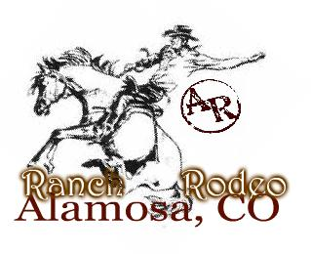

Ranch Rodeo Entry Form

Team Members (4)

Entry Fee $200 per team/ $50 per man

$50 Stock charge will be taken from each team entry.
$150 remaining entry fee will go towards the Prize $.
$1000 will be added by The Alamosa Round-UP.

Pay-off – to be determined by the number of teams entered.
1st Place Team Members- Custom Made Frontier Trophy Belt Buckle

Events will include:

Wild Cow Milking
Team Roping/Branding
Load em’ and Go Relay
Ranch River Relay

**Optional Ranch Bronc Riding for extra points**

Entry can be Mailed to:
Alamosa Round-UP
PO Box 59
Alamosa, CO 81101

